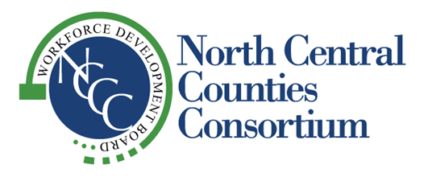
“Supporting Economic Vitality in the Counties of Colusa, Glenn, Sutter and Yuba”

NCCC
GOVERNING BOARD AND
WORKFORCE DEVELOPMENT BOARD
November 5, 2026
2:00 pm

Sutter County Superintendent of Schools
Boardroom
970 Klamath Lane
Yuba City, CA

A G E N D A

1. 2:00 Call to Order Daurice Kalfsbeek Smith

2. Pledge of Allegiance Daurice Kalfsbeek Smith

3. Roll Call Tisha Smith

4. 2:05 Welcome Daurice Kalfsbeek Smith

5. 2:10 Public Comment

6. 2:10 Governing Board Chair Passes Meeting over to Workforce Development Board Chair

7. 2:10 Approval of Minutes – John Fleming/Daurice Kalfsbeek Smith Action - WDB
(Attachment A) Action - GB
- August 20, 2026, Board Meeting

8. 2:15 Approval of New Grant Application – Rhea Burns Action – WDB
(Attachment B) Action - GB
- Farmworkers Advancement Program

9. 2:20 Strategic Workforce Development Plan Modification – Liz Barber Information
(Attachment C)

10. 2:25 Fiscal Committee Report – Glenn Denno Information
(Attachment D)

11. 2:40 Director’s Report – Liz Barber Information
12. 2:45 Local Business Presentation – Michele Bingham, CCOE Information

13. 3:00 Program Performance Report – Liz Barber Information
(Attachment E)

14. 3:00 Service Provider Updates Information
- Colusa
- Glenn
- Sutter
- Yuba
- Upward Bound

15. 3:25 Other Business Information
- NCCC Administrative Office Winter Schedule
- 2027 Board Meeting Schedule
- Next Board Meeting – Thursday, February 18, 2027

16. 3:30 Adjournment

Please note the listed times for agenda items are approximate and may change during the course of the meeting.
Agenda materials are provided to Board Members and One Stop Directors. Meeting agendas and minutes can be viewed on NCCC’s website at: http://www.northcentralcounties.com/wib.html. Other documents are available to the public upon request. NCCC is an equal opportunity employer/program. Auxiliary aids and services are available upon request to individuals with disabilities.

